Prayers for Sunday, 3rd May 2020
At the moment, we are a bit like the church in the time of Peter – we are in lockdown, hidden away, but still a community of faith and we can still pray to our God who hears us and loves us. So today we will pray in our houses, using each room or area as a focus for different prayer topics. You might like to put a post-it note in each place with the prayer headlines so that you can come back to them during the week …
Let’s start in our bedrooms: thank God for our places of safety, our comfortable beds and for the refreshment of rest. Ask God to bless people who aren’t sleeping well at the moment – remember, God is with you in those dark and lonely hours.  Then pray for those who don’t have anywhere safe and comfortable to rest at the moment; thank God for the hotels that have offered somewhere for people to stay and ask Him to strengthen those who are still working to provide places for those who need them. | 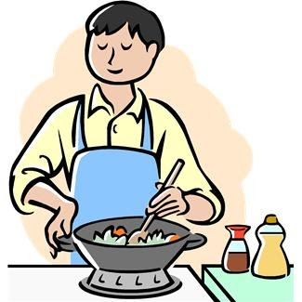  Let’s move into our kitchens: thank God for the staff in supermarkets and shops, the delivery drivers and warehouse staff who are working so hard to ensure that food reaches us.  Pray for all those involved in Food banks who are working so hard to support people who are short of food at this time.  Pray also for those people who are struggling to feed their families, that they will find the help they need and that they will know God’s love with them at this time.
Pop into the bathroom or loo and wash your hands while you thank God for all those working in our frontline health and care services. Ask God to bless and protect them. Thank God for their skills and expertise. Pray for those searching for a cure or a vaccine to protect us. | Sit down at your table or where you usually eat and pray for everyone in isolation, either together or alone: let’s pray that this time draws us closer to each other and to God.
Sit in front of your television for a moment and thank God for the ways that we can all be connected during these times; pray too for those who appear on our screens as leaders and guides through these difficult days and weeks, that they will have wisdom and compassion; also, let’s thank God for the talents of all those who are entertaining us at the moment. | Stand at your front door or pop out into your garden if you can: take a moment to thank God for the sheer beauty of the world around us and the glories of spring. Then let’s pray for our community, thanking God for those who have reached out and helped their neighbours during lockdown, and asking Him to show us where there is still need. We also pray that we can keep these new connections and support networks after the lockdown is over.

We’ll finish our prayers this morning with the Lord’s Prayer:

